Baroque Instruments

Baroque Violin

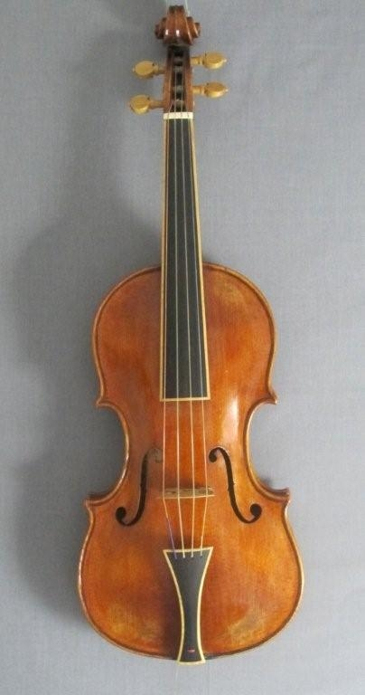
The violin that we perform on today was standardized around 1550 in Italy. It is recognized by its iconic shape, with four corners. Before the 16th century, when the violin, the soprano size of the viol family, was developed, the viola, the alto member of the family was the more commonly used bowed instrument. During the period of experimentation and changes in instrument making in the 16th century the entire consort of the violin family, the violin, the viola, the cello, and the bass, were developed, however they were not called by these names until later on.

When comparing the Baroque violin to the contemporary violin there are many differences in the physical and musical characteristics of the instruments. The neck is shorter than modern instruments, and was also fixed by nails or screws instead of mortised. The fingerboard was also shorter and shaped like a wedge. The Baroque instrument did not have a chin rest until much later, which meant the instrument had to be anchored against the left side of the chest, rather than on the shoulder. Bows were also shorter in the Baroque era, which accommodated virtuosic playing. With regard to tone, the Baroque violin has a brighter, clearer sound, whereas the modern violin has a warmer and more mellow sound. Many of these changes in the violin’s structure and sound from the Baroque to the Classical eras had to do with the change in aesthetic from more virtuosic playing to a smoother, more connected style.

Listening example: https://www.youtube.com/watch?v=SlO_VhEo6-E

Recorder

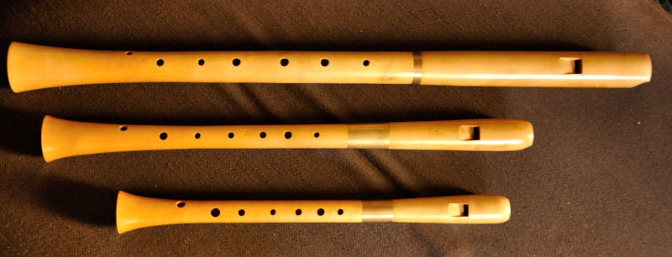
The recorder was the common flute of the Renaissance and Baroque eras. The recorder has a beak-shaped mouthpiece and a gentle sound. The recorder has a thumbhole and seven fingerholes. The name ‘recorder’ was used for this instrument in the late 14th century and by the 16th century the entire consort of recorders, from soprano to bass, were in use. Earlier recorders were crafted from a single piece of wood. By the Baroque era, however, they were created of three separate parts, a head, body and foot.

Use of the recorder died out in favour of the more expressive transverse flute during the Classical period. However, its use was revived in 1920 and now it is used as the ideal first instrument for a child, and is widely used in the performance of Baroque and other early music.

Listening example: https://www.youtube.com/watch?v=pooiSZ-Dx_c

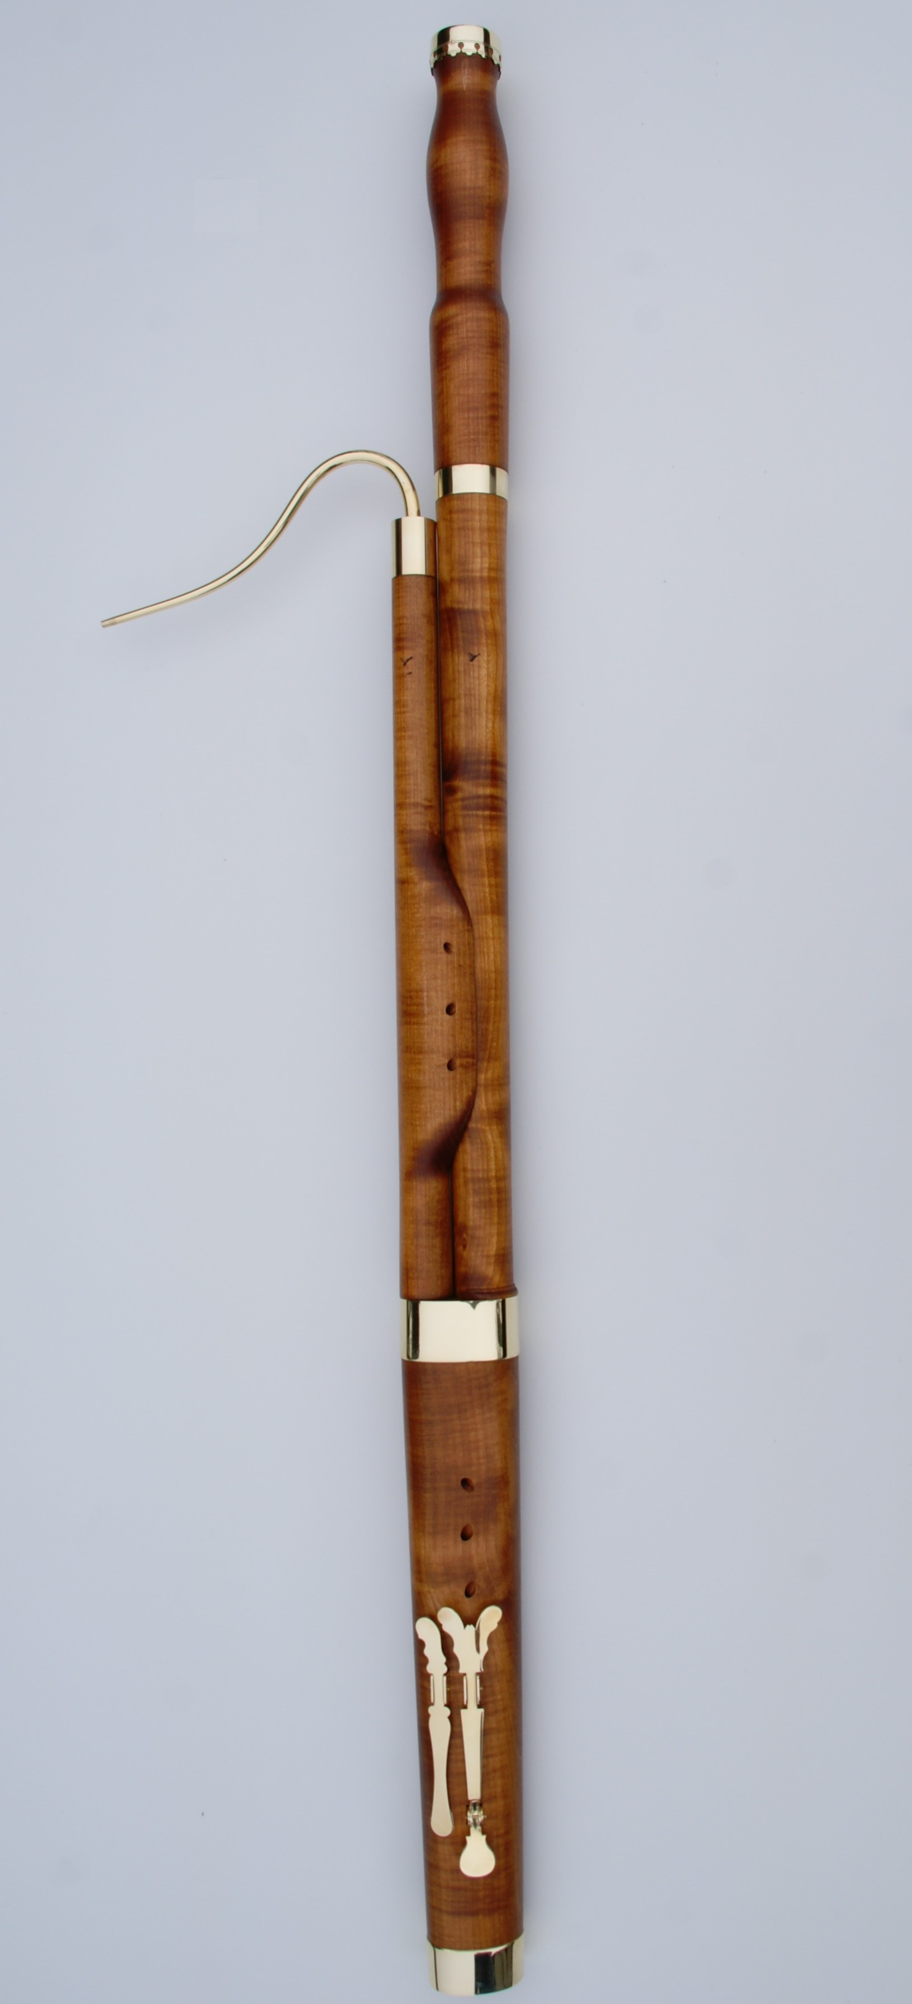
Bassoon

It is traditionally thought that the bassoon was developed in France during the time of Louis XIV. By the 1680s there were references to the instrument and Jean-Baptiste Lully even scored for bassoon in his 1680 opera Proserpine.

There were both 3- and 4-keyed versions of early bassoons, however, the 4-keyed bassoon became the standard for the duration of the 18th century. During the 18th century the tone of the bassoon became more mellow, with a greater expressive range. The expressiveness expected of the instrument by the late 18th century was evident in the works of Mozart.

During the 19th century, with further innovations in instrument making, the bassoon gained more keys to allow for more virtuosic playing and greater expressive range. These developments lead to the standardization of the modern-day bassoon.

Listening example: https://www.youtube.com/watch?v=i_p9GSXC4Dg

